SUBRECIPIENT DETERMINATION TOOL

Mason PI | First Name Last Name
Subrecipient Institution | Subrecipient Institution
OSP Administrator | Administrator First Name, Last Name
GMU Grant ID/Fund # | Grant # and/or Fund #
Date | Click or tap to enter a date.

This determination tool can be utilized to inform two key determinations related to Mason’s sponsored project subawards:
- The classification of a pass-through agreement as either a purchased services agreement (contractor) or subagreement
- Whether a pass-through agreement should be issued as a new subaward or an amendment to an existing subaward to the same subrecipient
For both considerations, the agreement type utilized should reflect the substantive nature of the relationship between Mason and the recipient entity with regard to the research award.
F&A charging and Mason monitoring responsibilities vary between contractors and subrecipients. The appropriate agreement determination should be made early in the grant application process to ensure the grant budget and narrative are prepared accurately. The agreement determination should be confirmed after an award is made so that appropriate monitoring procedures are established and incorporated into the pass-through agreement and the subaward can be set-up for appropriate indirect burdening in Banner.
The table below includes guidance from the 2 CFR § 200.330 Uniform Guidance regarding classification of a subrecipient versus a contractor relationship.
This form can be used to support and document Mason’s determination of the appropriate agreement type. This form is not required, but for any pass-through agreements when these determinations raise questions, OSP should use this form to facilitate the determination and document the outcomes.
Determination of Subrecipient vs. Contractor
Subrecipient  A subaward is for the purpose of carrying out a portion of a Federal award and creates a Federal assistance relationship with the subrecipient. See CFR §200.92 Subaward. Characteristics which support the classification of the non-Federal entity as a subrecipient include when the non-Federal entity:  - Determines who is eligible to receive what Federal assistance;  - Has its performance measured in relation to whether objectives of a Federal program were met;  - Has responsibility for programmatic decision-making;  - Is responsible for adherence to applicable Federal program requirements specified in the Federal award; and  - In accordance with its agreement, uses the Federal funds to carry out a program for a public purpose specified in authorizing statute, as opposed to providing goods or services for the benefit of the pass-through entity. | Contractor  A contract is for the purpose of obtaining goods and services for the non-Federal entity's own use and creates a procurement relationship with the contractor. See CFR §200.22 Contract. Characteristics indicative of a procurement relationship between the non-Federal entity and a contractor are when the contractor:  - Provides the goods and services within normal business operations;  - Provides similar goods or services to many different purchasers;  - Normally operates in a competitive environment;  - Provides goods or services that are ancillary to the operation of the Federal program; and  - Is not subject to compliance requirements of the Federal program as a result of the agreement, though similar requirements may apply for other reasons.

- SUBRECIPIENT VS. CONTRACTOR EVALUATION
This determination is not always straight-forward and the decision tree below is not a definitive direction on OSP’s final determination. Respond to each question below to guide the relationship determination for the pass-through agreement as a contractor or subrecipient.
Contractor vs Subrecipient: Evaluation Questions
Select | Is the recipient entity an individual?
Select | Is the recipient entity an organization?
Select | Do the activities described in the SOW provide benefit for a public purpose?
Select | Does the recipient entity have flexibility in how to implement the activities / execute the scope of work?
Select | Is the recipient entity contributing to programmatic decisions and direction?
Select | Is the recipient entity responsible for adherence to applicable Federal program requirements specified in the award?
Select | Is the recipient entity providing goods or services that it typically provides in a competitive / commercial environment?
Select | Is the recipient entity providing goods or services that are ancillary to the Federal program?
Select | Is the recipient entity providing similar goods and services to many different purchasers?
Select | Is the recipient entity providing goods and services within normal business operations?
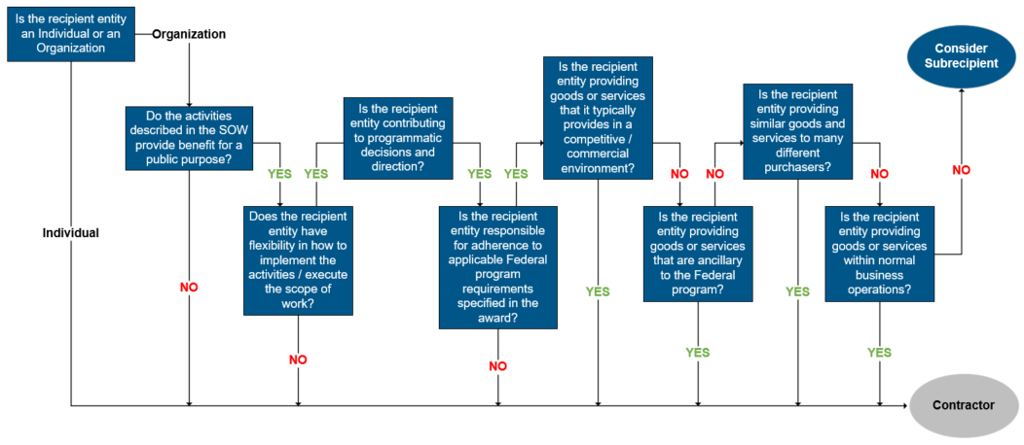
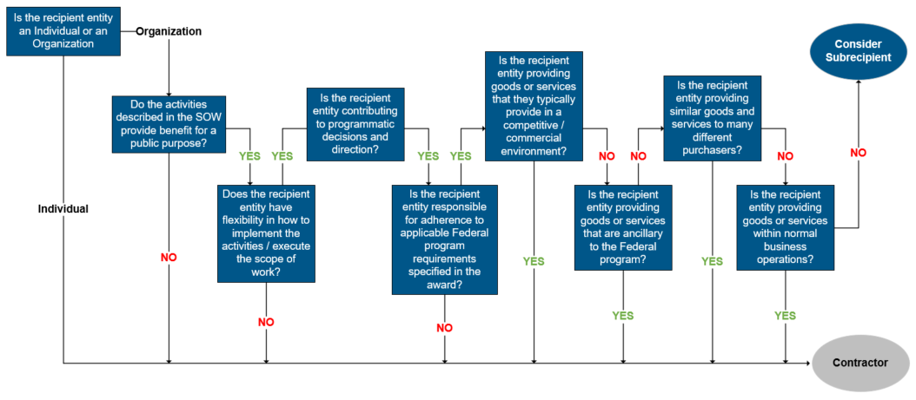
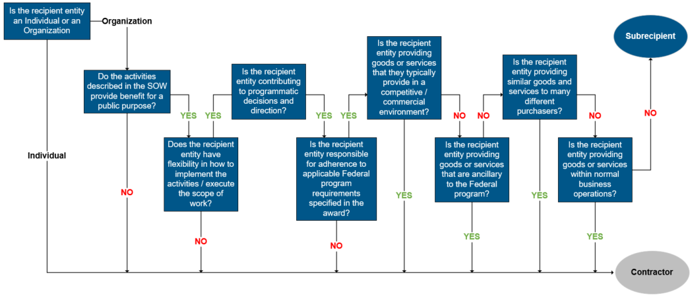
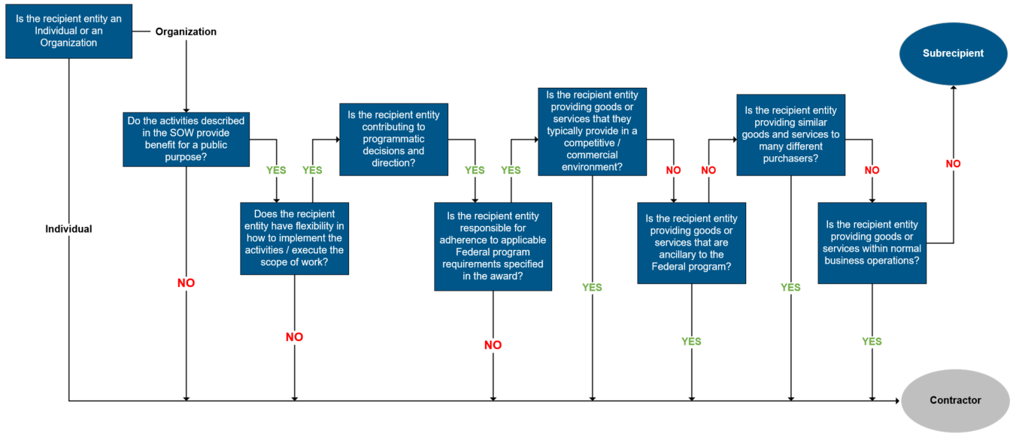
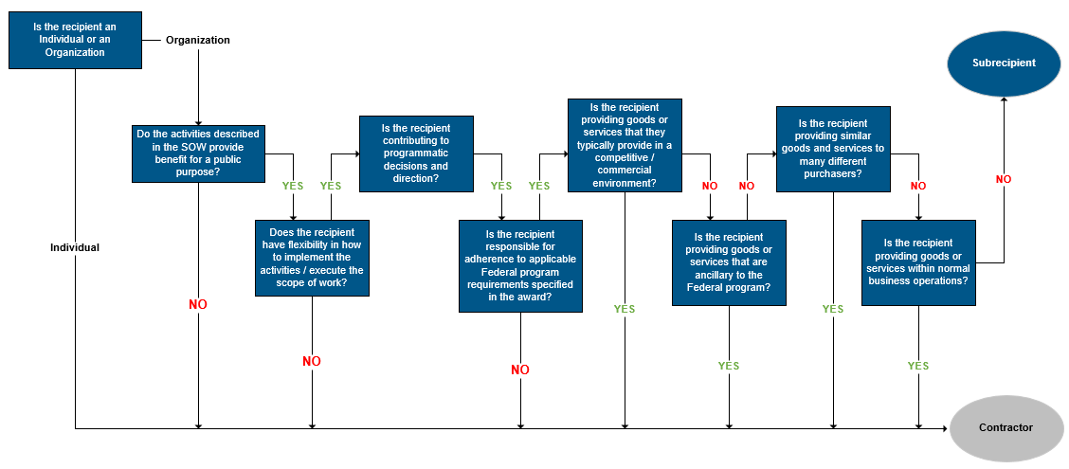
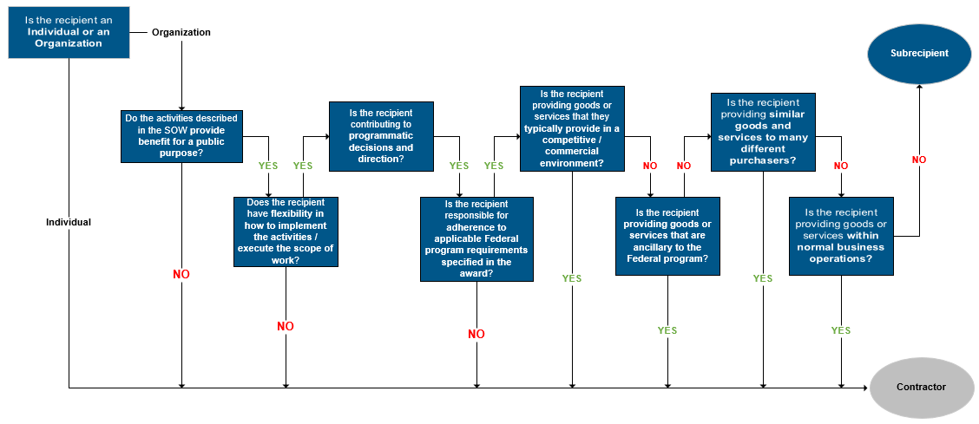
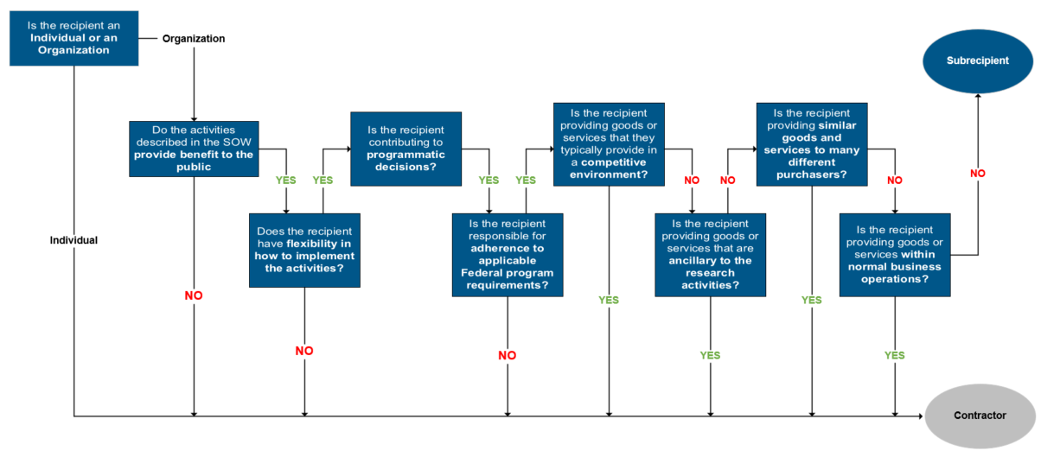

If the relationship is ambiguous, OSP (with input and perspective from the PI) should provide additional justification for the determination in the Use of Judgment section below.
Use of Judgement

Determination: | ☐Contractor | ☐Subrecipient

- NEW SUBAWARD VS. AMENDMENT EVALUATION
This determination is not always straight-forward and the decision tree below is not a definitive direction on OSP’s final determination. Respond to each question to guide the final determination on whether a new subaward should be issued or if an existing subaward should be amended / modified.
New Subaward vs. Amendment: Evaluation Questions
Select | Is the subaward scope of work distinctly different from an existing subaward?
Select | Is the subaward under a new / different subrecipient PI from an existing subaward?
Select | Is the subaward under a new / separate scope of work of the prime award (i.e. new Task Order, Supplemental Funding, etc.)?
Select | Does this subaward include unique / different flow down terms not applicable to an existing subaward?
